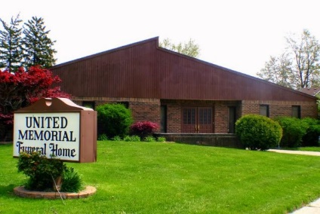
United Memorial Funeral Home
75 Dickinson St.
Mt. Clemens, MI. 48043
(586)463-8800 fax (586)463-8845 Email:admin@unitedmemorialfh.com
www.unitedmemorialfh.com Cynthia Howell, Funeral Director

Funeral arrangements for: Kenneth Lee Gwinn
Visitation: Friday, March 5, 2021 10:00 a.m -7:00 p.m.
Love Life Family Christian Center
17363 Toepher Drive
Eastpointe, MI. 48021

Funeral: Saturday, March 6, 2021 12:00 Noon
Love Life Family Christian Center
17363 Toepher Drive
Eastpointe, MI. 48021

Burial: Lincoln Memorial Park Cemetery

