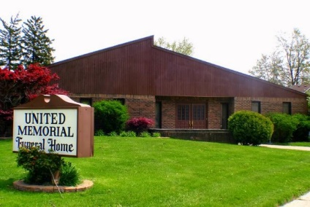
United Memorial Funeral Home
75 Dickinson St.
Mt. Clemens, MI. 48043
(586)463-8800 fax (586)463-8845 Email:admin@unitedmemorialfh.com
www.unitedmemorialfh.com Cynthia Howell, Funeral Director

Funeral arrangements for: Helen Meaders

Family Hour: Wednesday, December 22, 2021 10:00 a.m.
Greater Morning Star Missionary Baptist Church
87 Robertson St.
Mount Clemens, MI. 48043

Funeral: Wednesday, December 22, 2021 11:00 a.m.
Greater Morning Star Missionary Baptist Church
87 Robertson St.
Mount Clemens, MI. 48043
Burial: Lincoln Memorial Park Cemetery

