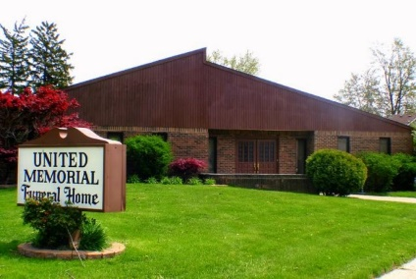
United Memorial Funeral Home
75 Dickinson St.
Mt. Clemens, MI. 48043
(586)463-8800 fax (586)463-8845 Email:admin@unitedmemorialfh.com
www.unitedmemorialfh.com Cynthia Howell, Funeral Director

Funeral arrangements for: Dennis Willis
Family Hour: Friday, February 5, 2021 12:00 Noon
New Calvary Baptist Church
3975 Concord Ave.
Detroit, MI. 48207
Funeral: Friday, February 5, 2021 12:30 p.m.
New Calvary Baptist Church
3975 Concord Ave.
Detroit, MI. 48207

Burial: Woodlawn Cemetery

