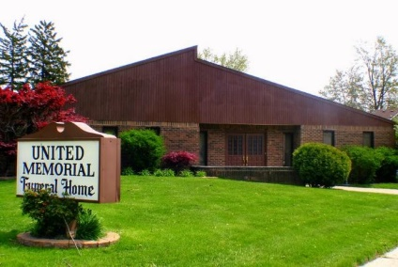
United Memorial Funeral Home
75 Dickinson St.
Mt. Clemens, MI. 48043
(586)463-8800 fax (586)463-8845 Email:admin@unitedmemorialfh.com
www.unitedmemorialfh.com Cynthia Howell, Funeral Director

Funeral arrangements for: Vina Key
Visitation: Wednesday, March 31, 2021 1:00 p.m. – 5:00 p.m.
United Memorial Funeral Home
75 Dickinson St.
Mt. Clemens, MI. 48043
Family Hour: Thursday, April 1, 2021 10:00 a.m.
True Love Christian Ministries
6138 Nevada
Detroit, MI. 48235
Funeral: Thursday, April 1, 2021 11:00 a.m.
True Love Christian Ministries
6138 Nevada
Detroit, MI. 48235
Burial: Lincoln Memorial Park Cemetery

