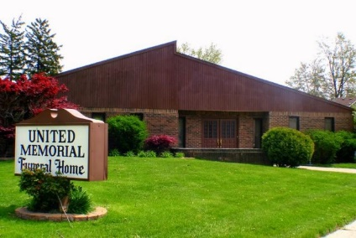
United Memorial Funeral Home
75 Dickinson St.
Mt. Clemens, MI. 48043
(586)463-8800 fax (586)463-8845 Email:admin@unitedmemorialfh.com
www.unitedmemorialfh.com Cynthia Howell, Funeral Director

Funeral arrangements for: Billy Gantt, Sr.

Visitation: Friday, December 17, 2021 1:00 p.m. – 6:00 p.m.
United Memorial Funeral Home
75 Dickinson St.
Mt. Clemens, MI. 48043
Funeral: Saturday, December 18, 2021 9:30 a.m.
North Broadway Church of Christ
260 North Broadway St.
Mt. Clemens, MI. 48043
Burial: Clinton Grove Cemetery

