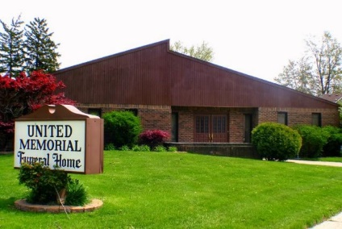
United Memorial Funeral Home
75 Dickinson St.
Mt. Clemens, MI. 48043
(586)463-8800 fax (586)463-8845 Email:admin@unitedmemorialfh.com
www.unitedmemorialfh.com Cynthia Howell, Funeral Director

Funeral arrangements for: James Platt

Family Hour: Saturday, September 19, 2020 9:00 a.m.
United Memorial Funeral Home
75 Dickinson St.
Mount Clemens, MI. 48043
Funeral: Saturday, September 19, 2020 10:00 a.m.
United Memorial Funeral Home
75 Dickinson St.
Mount Clemens, MI. 48043
Burial: Clinton Grove Cemetery

