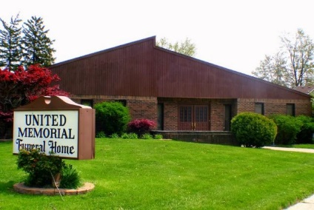
United Memorial Funeral Home
75 Dickinson St.
Mt. Clemens, MI. 48043
(586)463-8800 fax (586)463-8845 Email:admin@unitedmemorialfh.com
www.unitedmemorialfh.com Cynthia Howell, Funeral Director

Funeral arrangements for: Marlon Henry Jr.
Visitation: Saturday, March 12, 2021 2:00 p.m. - 7:00 p.m.
United Memorial Funeral Home
75 Dickinson Street
Mt. Clemens, Michigan 48043
Family Hour: Saturday, March 13, 2021 11:00 a.m.
Tried Stone Missionary Baptist Church
23512 Joy Blvd.
Clinton Township, MI. 48036
Funeral: Saturday, March 13, 2021 12:00 Noon
Tried Stone Missionary Baptist Church
23512 Joy Blvd.
Clinton Township, MI. 48036
Burial: Lincoln Memorial Park Cemetery

