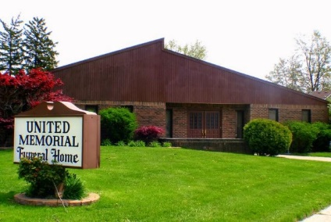
United Memorial Funeral Home
75 Dickinson St.
Mt. Clemens, MI. 48043
(586)463-8800 fax (586)463-8845 Email:admin@unitedmemorialfh.com
www.unitedmemorialfh.com Cynthia Howell, Funeral Director

Funeral arrangements for: Tracy Williamson
Visitation: Sunday, May 23, 2021 2:00p.m. – 6:00 p.m.
United Memorial Funeral Home
75 Dickinson St.
Mt. Clemens, MI. 48043

Funeral: Monday, May 24, 2021 11:00 a.m.
King of Kings
6375 Inkster
Taylor, MI. 48180

Burial: Lincoln Memorial Park Cemetery

