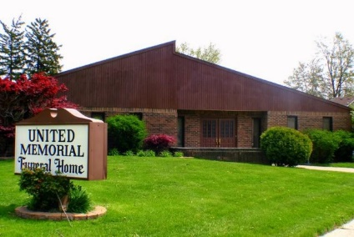
United Memorial Funeral Home
75 Dickinson St.
Mt. Clemens, MI. 48043
(586)463-8800 fax (586)463-8845 Email:admin@unitedmemorialfh.com
www.unitedmemorialfh.com Cynthia Howell, Funeral Director

Funeral arrangements for: Cynthia Dorthia Walker Gomez

Family Hour: Saturday, March 7, 2020 11:00 a.m.
North Broadway Church of Christ
260 North Broadway St.
Mt. Clemens, MI. 48043
Funeral: Saturday, March 7, 2020 12:00 Noon
North Broadway Church of Christ
260 North Broadway St.
Mt. Clemens, MI. 48043
Officiating: Dr. Harry C. Washington III
Burial: Lincoln Memorial Cemetery

