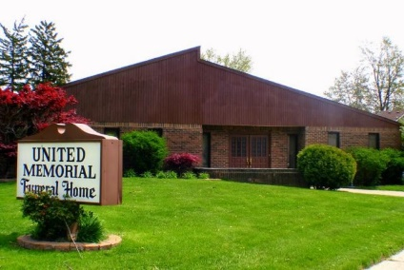
United Memorial Funeral Home
75 Dickinson St.
Mt. Clemens, MI. 48043
(586)463-8800 fax (586)463-8845 Email:admin@unitedmemorialfh.com
www.unitedmemorialfh.com Cynthia Howell, Funeral Director

Funeral arrangements for: Harvey Lee Harris
Family Hour: Saturday, February 22, 2020 10:00 a.m.
Tried Stone Missionary Baptist Church
23512 Joy Blvd.
Clinton Township, MI. 48036
Funeral: Saturday, February 22, 2020 11:00 a.m.
Tried Stone Missionary Baptist Church
23512 Joy Blvd.
Clinton Township, MI. 48036
Officiating: Rev. Terence Standifer

Burial: Lincoln Memorial Park Cemetery

