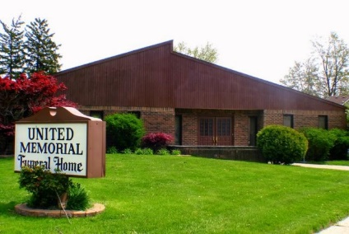
United Memorial Funeral Home
75 Dickinson St.
Mt. Clemens, MI. 48043
(586)463-8800 fax (586)463-8845 Email:admin@unitedmemorialfh.com
www.unitedmemorialfh.com Cynthia Howell, Funeral Director

Funeral arrangements for: Ida Banks
Visitation: Thursday, July 8, 2021 2:00 – 6:00 p.m.
United Memorial Funeral Home
75 Dickinson St.
Mt. Clemens, MI. 48043
Family Hour: Friday, July 9, 2021 12:00 Noon
Vinson Chapel AME
22435 Quinn Rd.
Clinton Township, MI. 48035
Funeral: Friday, July 9, 2021 1:00 p.m.
Vinson Chapel AME
22435 Quinn Rd.
Clinton Township, MI. 48035

