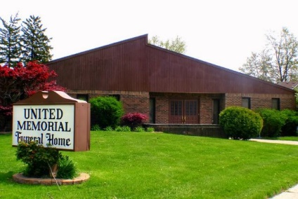
United Memorial Funeral Home
75 Dickinson St.
Mt. Clemens, MI. 48043
(586)463-8800 fax (586)463-8845 Email:admin@unitedmemorialfh.com
www.unitedmemorialfh.com Cynthia Howell, Funeral Director

Funeral arrangements for: Alexandria Boyd
Visitation: Saturday, March 13, 2021 9:00 a.m. -10:30 a.m.
United Memorial Funeral Home
75 Dickinson Street
Mt. Clemens, Michigan 48043

Funeral: Saturday, March 13, 2021 10:30 a.m.
United Memorial Funeral Home
75 Dickinson Street
Mt. Clemens, Michigan 48043

Burial: Clinton Grove Cemetery

