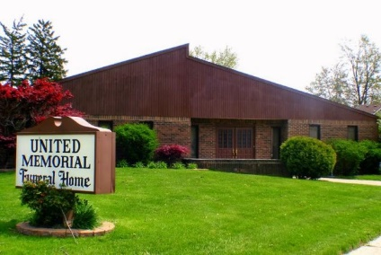
United Memorial Funeral Home
75 Dickinson St.
Mt. Clemens, MI. 48043
(586)463-8800 fax (586)463-8845 Email:admin@unitedmemorialfh.com
www.unitedmemorialfh.com Cynthia Howell, Funeral Director

Funeral arrangements for: Harold C. Henry
Visitation: Friday, January 29, 2021 12:00 Noon – 6:00 p.m.
United Memorial Funeral Home
75 Dickinson St.
Mt. Clemens, MI 48043

Funeral: Saturday, January 30, 2021 11:00 a.m.
United Memorial Funeral Home
75 Dickinson St.
Mt. Clemens, MI. 48043
Burial: Lincoln Memorial Park Cemetery

