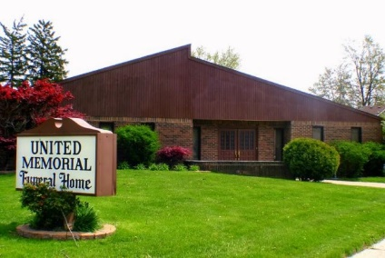
United Memorial Funeral Home
75 Dickinson St.
Mt. Clemens, MI. 48043
(586)463-8800 fax (586)463-8845 Email:admin@unitedmemorialfh.com
www.unitedmemorialfh.com Cynthia Howell, Funeral Director
*****REVISION: NOTICE LOCATION CHANGE****

Funeral arrangements for: Tamairis Ireland
Visitation: Friday, November 5, 2021 2:00 pm – 6:00 pm
United Memorial Funeral Home
75 Dickinson St.
Mount Clemens, MI. 48043
Family Hour: Saturday, November 6, 2021 9:00 a.m.
Greater Morning Star Missionary Baptist Church
87 Robertson
Mt. Clemens, MI. 48043
Funeral: Saturday, November 6, 2021 10:00 a.m.
Greater Morning Star Missionary Baptist Church
87 Robertson
Mt. Clemens, MI. 48043
Burial: Clinton Grove Cemetery

