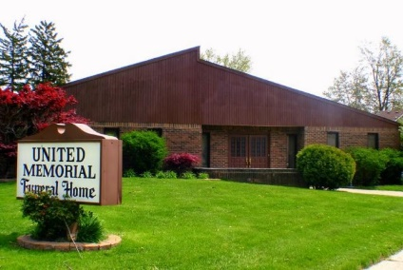
United Memorial Funeral Home
75 Dickinson St.
Mt. Clemens, MI. 48043
(586)463-8800 fax (586)463-8845 Email:admin@unitedmemorialfh.com
www.unitedmemorialfh.com Cynthia Howell, Funeral Director

Funeral arrangements for: Lillie Tennessee
Visitation: Friday, October 22, 2021 2:00 pm – 6:00 pm
United Memorial Funeral Home
75 Dickinson St.
Mount Clemens, MI. 48043
Family Hour: Saturday, October 23, 2021 11:00 a.m.
United Memorial Funeral Home
75 Dickinson St.
Mount Clemens, MI. 48043
Funeral: Saturday, October 23, 2021 12:00 Noon
United Memorial Funeral Home
75 Dickinson St.
Mount Clemens, MI. 48043
Burial: Lincoln Memorial Park

