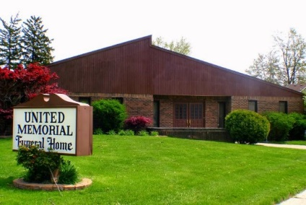
United Memorial Funeral Home
75 Dickinson St.
Mt. Clemens, MI. 48043
(586)463-8800 fax (586)463-8845 Email:admin@unitedmemorialfh.com
www.unitedmemorialfh.com Cynthia Howell, Funeral Director

Funeral arrangements for: Ola Arnold
Visitation: Wednesday, June 9, 2021 2:00 p.m. – 6:00 p.m.
United Memorial Funeral Home
75 Dickinson St.
Mt. Clemens, MI. 48043
Family Hour: Thursday, June 10, 2021 10:00 a.m.
Winner’s Circle Church
258 S. Gratiot
Mt. Clemens, MI. 48043
Funeral: Thursday, June 10, 2021 11:00 a.m.
Winner’s Circle Church
258 S. Gratiot
Mt. Clemens, MI. 48043
Cemetery: Clinton Grove

