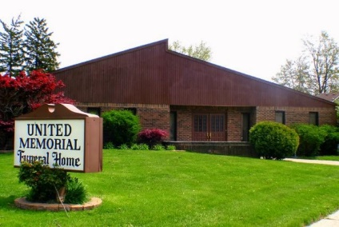
United Memorial Funeral Home
75 Dickinson St.
Mt. Clemens, MI. 48043
(586)463-8800 fax (586)463-8845 Email:admin@unitedmemorialfh.com
www.unitedmemorialfh.com Cynthia Howell, Funeral Director

Funeral arrangements for: Andrew Lee Wright

Visitation: Friday, February 28, 2020, 1:00 p.m.- 8:00 p.m.
United Memorial Funeral Home
75 Dickinson St.
Mt. Clemens, MI. 48043
Funeral: Saturday, February 29, 2020 12:00 Noon
United Memorial Funeral Home
75 Dickinson St.
Mt. Clemens, MI. 48043
Burial: Porter’s Memorial Garden in Tupelo, Mississippi

