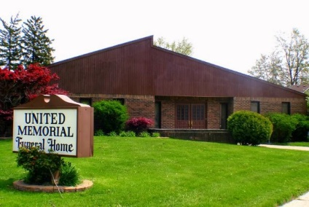
United Memorial Funeral Home
75 Dickinson St.
Mt. Clemens, MI. 48043
(586)463-8800 fax (586)463-8845 Email:admin@unitedmemorialfh.com
www.unitedmemorialfh.com Cynthia Howell, Funeral Director

Funeral arrangements for: Bobby Carreker
Visitation: Tuesday, September 13, 2022 2:00 – 7:00 p.m.
United Memorial Funeral Home
75 Dickinson St.
Mt. Clemens, MI. 48043
Family Hour: Wednesday, September 14, 2022 10:30 a.m.
Greater Morning Star Missionary Baptist Church
87 Robertson St.
Mount Clemens, MI. 48043
Funeral: Wednesday, September 14, 2022 11:00 a.m.
Greater Morning Star Missionary Baptist Church
87 Robertson St.
Mount Clemens, MI. 48043
Burial: Great Lakes National Cemetery

