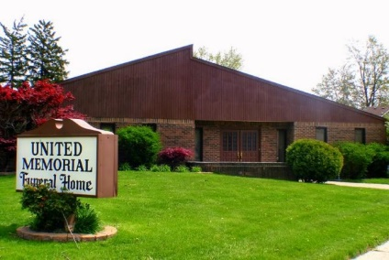
United Memorial Funeral Home
75 Dickinson St.
Mt. Clemens, MI. 48043
(586)463-8800 fax (586)463-8845 Email:admin@unitedmemorialfh.com
www.unitedmemorialfh.com Cynthia Howell, Funeral Director

Funeral arrangements for: Delen Jones Eberhardt Houle

Visitation: Friday, December 18, 2020 1:00 p.m.-5:00 p.m.
United Memorial Funeral Home
75 Dickinson St.
Mt. Clemens, MI. 48043
Funeral: Saturday, December 19, 2020 11:00 a.m.(at the gravesite)
Graveside @ Clinton Grove Cemetery
Mt. Clemens, Mi. 48043

