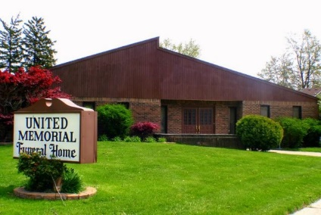
United Memorial Funeral Home
75 Dickinson St.
Mt. Clemens, MI. 48043
(586)463-8800 fax (586)463-8845 Email:admin@unitedmemorialfh.com
www.unitedmemorialfh.com Cynthia Howell, Funeral Director

Funeral arrangements for: Marilyn D. Wright-Stewart
Visitation: Friday, February 11, 2022 2:00 – 6:00 p.m.
United Memorial Funeral Home
75 Dickinson St.
Mount Clemens, MI. 48043

Family Hour: Saturday, February 12, 2022 10:00 a.m.
Church of the Living God
10113 West 8 Mile Road
Detroit, MI. 48221

Funeral: Saturday, February 12, 2022 10:30 a.m.
Church of the Living God
10113 West 8 Mile Road
Detroit, MI. 48221

Burial: Lincoln Memorial Park Cemetery

