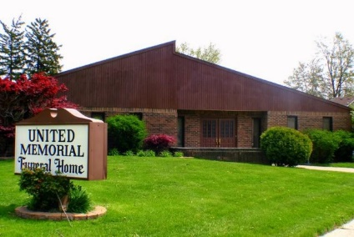
United Memorial Funeral Home
75 Dickinson St.
Mt. Clemens, MI. 48043
(586)463-8800 fax (586)463-8845 Email:admin@unitedmemorialfh.com
www.unitedmemorialfh.com Cynthia Howell, Funeral Director

Funeral arrangements for: Arnold Horton
Visitation: Friday, December 10, 2021 3:00 p.m. – 6:00 p.m.
United Memorial Funeral Home
75 Dickinson St.
Mt. Clemens, MI. 48043
Family Hour: Saturday, December 11, 2021 11:00 a.m.
Restoration By Christ Ministries
16675 Frazho Road
Roseville, MI. 48066
Funeral: Saturday, December 11, 2021 11:30 a.m.
Restoration By Christ Ministries
16675 Frazho Road
Roseville, MI. 48066

Burial: Lincoln Memorial Park Cemetery

