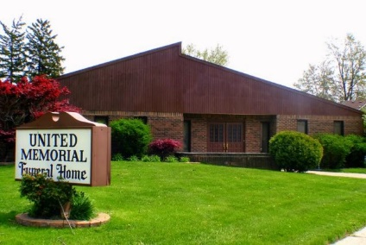
United Memorial Funeral Home
75 Dickinson St.
Mt. Clemens, MI. 48043
(586)463-8800 fax (586)463-8845 Email:admin@unitedmemorialfh.com
www.unitedmemorialfh.com Cynthia Howell, Funeral Director

Funeral arrangements for: Cornelius Edwards Jr.

Visitation: Saturday, July 18, 2020 12:00 – 4:00 p.m.
United Memorial Funeral Home
75 Dickinson St.
Mt. Clemens, MI. 48043

Funeral: Saturday, July 18, 2020 4:00 p.m.
United Memorial Funeral Home
75 Dickinson St.
Mt. Clemens, MI. 48043
Burial: Clinton Grove Cemetery

