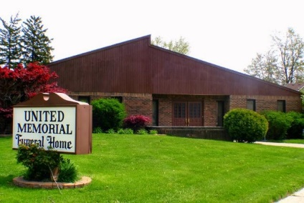
United Memorial Funeral Home
75 Dickinson St.
Mt. Clemens, MI. 48043
(586)463-8800 fax (586)463-8845 Email:admin@unitedmemorialfh.com
www.unitedmemorialfh.com Cynthia Howell, Funeral Director

Funeral arrangements for: Veodis Fernandis

Family Hour: Saturday, February 5, 2022 9:30 a.m.
Calvary Missionary Baptist Church
67 Southbound Gratiot, Ave.
Mount Clemens, MI. 48043

Funeral: Saturday, February 5, 2022 10:30 a.m.
Calvary Missionary Baptist Church
67 Southbound Gratiot, Ave.
Mount Clemens, MI. 48043

Burial: Clinton Grove Cemetery

