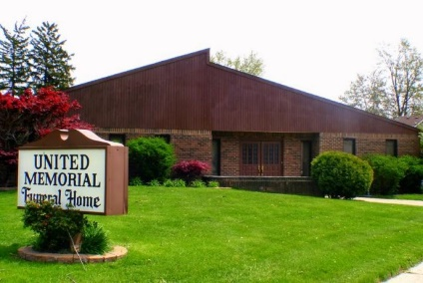
United Memorial Funeral Home
75 Dickinson St.
Mt. Clemens, MI. 48043
(586)463-8800 fax (586)463-8845 Email:admin@unitedmemorialfh.com
www.unitedmemorialfh.com Cynthia Howell, Funeral Director

Funeral arrangements for: Thelma Allen
Visitation: Monday, March 1, 2021 1:00 p.m. -5:00 p.m.
United Memorial Funeral Home
75 Dickinson St.
Mt. Clemens, MI. 48043
Family Hour: Tuesday, March 2, 2021 11:00 a.m.
United Memorial Funeral Home
75 Dickinson St.
Mt. Clemens, MI. 48043
Funeral: Tuesday, March 2, 2021 12:00 Noon
United Memorial Funeral Home
75 Dickinson St.
Mt. Clemens, MI. 48043

