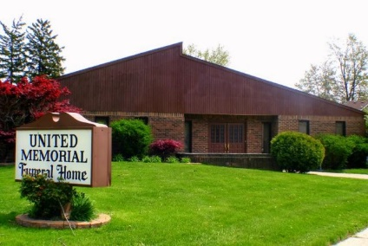
United Memorial Funeral Home
75 Dickinson St.
Mt. Clemens, MI. 48043
(586)463-8800 fax (586)463-8845 Email:admin@unitedmemorialfh.com
www.unitedmemorialfh.com Cynthia Howell, Funeral Directress

Arrangements for: Donald Becks Jr.
Visitation: Thursday, February 3, 2022 2:00-7:00 pm
United Memorial Funeral Home
75 Dickinson St.
Mt. Clemens, MI. 48043
****
Life Celebration
Friday, February 4, 2022 1:00-5:00pm (upstairs-elevator available)
At
Total Sports
40501 Production Dr.
Harrison Twp., MI. 48045

Family is requesting all donations to be sent to: cashapp: $Tracirubin or paypal: meanoline@yahoo.com or United Memorial Funeral Home

