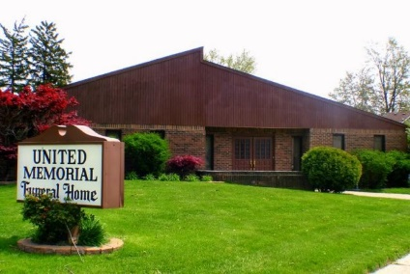
United Memorial Funeral Home
75 Dickinson St.
Mt. Clemens, MI. 48043
(586)463-8800 fax (586)463-8845 Email:admin@unitedmemorialfh.com
www.unitedmemorialfh.com Cynthia Howell, Funeral Director
****REVISION*****
Funeral arrangements for: Rose Pearl Adams
Visitation: Thursday, April 15, 2021 4:00 p.m.- 7:00 p.m.
United Memorial Funeral Home
75 Dickinson St.
Mt. Clemens, MI. 48043
Family Hour: Friday, April 16, 2021 11:00 a.m.
Tried Stone Missionary Baptist Church
23512 Joy Blvd.
Clinton Township, MI. 48036
Funeral: Friday, April 16, 2021 11:30 a.m.
Tried Stone Missionary Baptist Church
23512 Joy Blvd.
Clinton Township, MI. 48036

