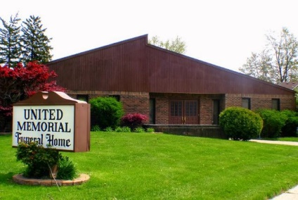
United Memorial Funeral Home
75 Dickinson St.
Mt. Clemens, MI. 48043
(586)463-8800 fax (586)463-8845 Email:admin@unitedmemorialfh.com
www.unitedmemorialfh.com Cynthia Howell, Funeral Director

Funeral arrangements for: Harvey Robinson

Family Hour: Friday, February 4, 2022 11:00 a.m.
United Memorial Funeral Home
75 Dickinson St.
Mount Clemens, MI. 48043

Funeral: Friday, February 4, 2022 12:00 Noon
United Memorial Funeral Home
75 Dickinson St.
Mount Clemens, MI. 48043
Burial: Clinton Grove Cemetery

