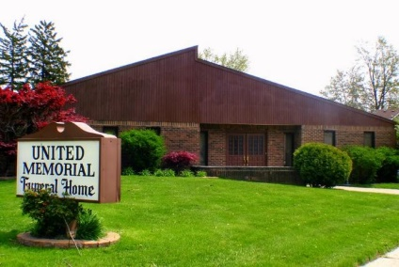
United Memorial Funeral Home
75 Dickinson St.
Mt. Clemens, MI. 48043
(586)463-8800 fax (586)463-8845 Email:admin@unitedmemorialfh.com
www.unitedmemorialfh.com Cynthia Howell, Funeral Director

Funeral arrangements for: Sheryl Emerson

Visitation: Friday, July 17, 2020 2:00 – 7:00 p.m.
United Memorial Funeral Home
75 Dickinson St.
Mt. Clemens, MI. 48043
Family Hour: Saturday, July 18, 2020 10:00 a.m.
Love Life Family Christian Center
17363 Toepher Drive
Eastpointe, MI. 48021
Funeral: Saturday, July 18, 2020 11:00 a.m.
Love Life Family Christian Center
17363 Toepher Drive
Eastpointe, MI. 48021

Officating: Pastor Kevin W. Lancaster

