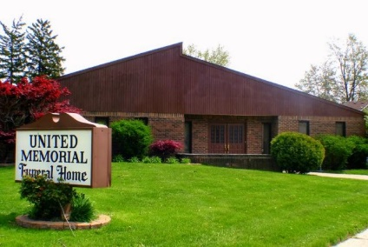
United Memorial Funeral Home
75 Dickinson St.
Mt. Clemens, MI. 48043
(586)463-8800 fax (586)463-8845 Email:admin@unitedmemorialfh.com
www.unitedmemorialfh.com Cynthia Howell, Funeral Director

Funeral arrangements for: Lanie Mae Hadley
Visitation: Monday, September 20, 2021 1:00 p.m. - 6:00 p.m.
United Memorial Funeral Home
75 Dickinson St.
Mt. Clemens, MI. 48043
Family Hour: Tuesday, September 21, 2021 10:00 a.m.
New Life In Christ Church
42 Moser Place
Mt. Clemens, MI. 48043
Funeral: Tuesday, September 21, 2021 11:00
New Life In Christ Church
42 Moser Place
Mt. Clemens, MI. 48043

Burial: Lincoln Memorial Park Cemetery

