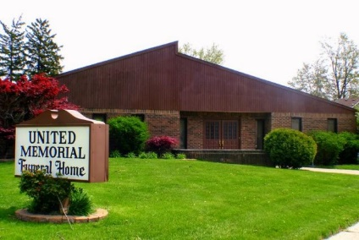
United Memorial Funeral Home
75 Dickinson St.
Mt. Clemens, MI. 48043
(586)463-8800 fax (586)463-8845 Email:admin@unitedmemorialfh.com
www.unitedmemorialfh.com Cynthia Howell, Funeral Director

Funeral arrangements for: Martha Scott
Visitation: Thursday, June 24, 2021 2:00-6:00p.m.
United Memorial Funeral Home
75 Dickinson St.
Mt. Clemens, MI. 48043

Family Hour: Friday, June 25, 2021 11:00 a.m.
New Life Ambassador for Christ Church
32500 Utica Rd.
Fraser, MI. 48026

Funeral: Friday, June 25, 2021 12:00 Noon
New Life Ambassador for Christ Church
32500 Utica Rd.
Fraser, MI. 48026

