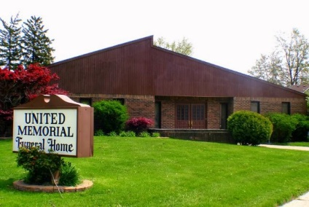
United Memorial Funeral Home
75 Dickinson St.
Mt. Clemens, MI. 48043
(586)463-8800 fax (586)463-8845 Email:admin@unitedmemorialfh.com
www.unitedmemorialfh.com Cynthia Howell, Funeral Director

Funeral arrangements for: Tyrone N. Harris
Visitation: Friday, August 21, 2020 12:00 p.m. 3:30 p.m.
Chapel of McFall
12530 East Seven Mile @ Barlow
Detroit, MI.
Funeral: Friday, August 21, 2020 3:30 p.m.
Chapel of McFall
12530 East Seven Mile @ Barlow
Detroit, MI.

Burial: Great Lakes Cemetery

