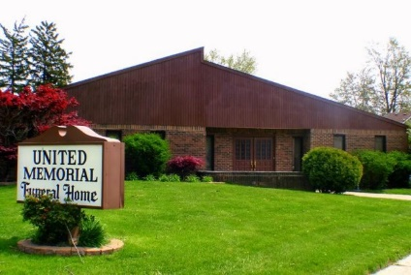
United Memorial Funeral Home
75 Dickinson St.
Mt. Clemens, MI. 48043
(586)463-8800 fax (586)463-8845 Email:admin@unitedmemorialfh.com
www.unitedmemorialfh.com Cynthia Howell, Funeral Director

Funeral arrangements for: Linda Dixon
Visitation: Friday, June 4, 2021 10:00 a.m. – 12:00 noon
United Memorial Funeral Home
75 Dickinson St.
Mt. Clemens, MI. 48043

Funeral: Friday, June 4, 2021 1:00 p.m.
United Memorial Funeral Home
75 Dickinson St.
Mt. Clemens, MI. 48043

