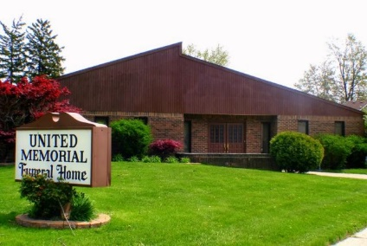
United Memorial Funeral Home
75 Dickinson St.
Mt. Clemens, MI. 48043
(586)463-8800 fax (586)463-8845 Email:admin@unitedmemorialfh.com
www.unitedmemorialfh.com Cynthia Howell, Funeral Director

Funeral arrangements for: D’Mario Cannon
Visitation: Friday, January 21, 2022 2:00 – 8:00 p.m.
United Memorial Funeral Home
75 Dickinson St.
Mt. Clemens, MI. 48043
Family Hour: Saturday, January 22, 2022 11:00 a.m.
Winner’s Circle Church
258 S. Gratiot Ave.
Mount Clemens, MI. 48043

Funeral: Saturday, January 22, 2022 12:00 Noon
Winner’s Circle Church
258 S. Gratiot Ave.
Mount Clemens, MI. 48043

