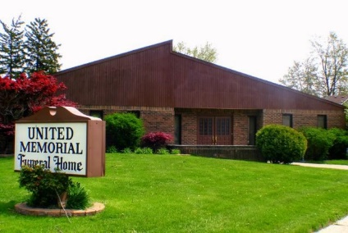
United Memorial Funeral Home
75 Dickinson St.
Mt. Clemens, MI. 48043
(586)463-8800 fax (586)463-8845 Email:admin@unitedmemorialfh.com
www.unitedmemorialfh.com Cynthia Howell, Funeral Director

Funeral arrangements for: Johathan (Splib) Neal
Visitation: Wednesday, July 20, 2022 10:00 a.m.-12:00 Noon
United Memorial Funeral Home
75 Dickinson St.
Mount Clemens, MI. 48043
Family Hour: Wednesday July 20, 2022 12:00 Noon
United Memorial Funeral Home
75 Dickinson St.
Mount Clemens, MI. 48043

Funeral: Wednesday, July 20, 2022 1:00 p.m.
United Memorial Funeral Home
75 Dickinson St.
Mount Clemens, MI. 48043

